Type of the Paper (Article, Review, Communication, etc.)

Title: Designing a Hybrid Network Monitoring System with Emergency Response System for Underground Mine

Firstname Lastname 1, Firstname Lastname 2 and Firstname Lastname 2, *

|  |
| --- |
| Academic Editor: Firstname Lastname  Received: date  Revised: date  Accepted: date  Published: date  **Citation:** To be added by editorial staff during production.  **Copyright:** © 2025 by the authors. Submitted for possible open access publication under the terms and conditions of the Creative Commons Attribution (CC BY) license (https://creativecommons.org/licenses/by/4.0/). |

1 Affiliation 1; e-mail@e-mail.com

2 Affiliation 2; e-mail@e-mail.com

**\*** Correspondence: e-mail@e-mail.com; Tel.: (optional; include country code; if there are multiple corresponding authors, add author initials)

**Abstract:** The research paper presents the design and implementation of a hybrid air quality monitoring system in underground mines. The system addresses health and safety issues posed by air pollution from drilling and blasting, geological strata, and heavy machines. The designed system monitors underground parameters like carbon monoxide, carbon dioxide, temperature, humidity, and particulate matter PM2.5 and PM10. These parameters are the key contributors to respiratory illness and black lung disease in underground miners, mainly artisanal and small-scale miners. The system uses MQ7, MQ135, DHT11, and SDS001 sensors to measure the underground parameters. The data from the sensors are processed by the Arduino (Microcontroller), and immediate feedback is provided through the buzzer when the parameter thresholds are exceeded. The Xbee modules transmit data from the sensor node to router nodes. The data is transmitted further from the router nodes to Raspberry Pi through fiber optics. The data in Raspberry Pi is further analyzed for improved emergency response. The proposed design bridges the gap between wireless technology and traditional wired methods by offering more efficient and reliable solutions. The system ensures robust data collection and transmission while enhancing miner safety and contributing to better management of underground environments. The research findings showcase the potential of integrating emerging technologies to address underground health issues.

**Keywords:** keyword 1: hybrid; keyword 2: sensor; keyword 3: air quality (List three to ten pertinent keywords specific to the article yet reasonably common within the subject discipline.)

1. Introduction

Underground mining is the extraction of valuable minerals such as gold, diamonds, rare earth elements, and tsavorite beneath the earth's surface. This method is usually used when surface mining is considered uneconomical. The increased demand for non-renewable natural resources combined with the depletion of shallow minerals from the earth's surface has fueled the growth of underground mining globally. An underground mine is formed through repetitive drilling and blasting of hard rocks using explosives such as ANFOs. However, these activities release harmful by-products such as carbon monoxide, carbon dioxide, sulfide, and nitrogen oxide gases. The tunnel formed due to continuous drilling and blasting is confined due to poor ventilation. [1], [2].

The underground mines' harsh and confined working conditions have posed several challenges to the miners. This includes dust and diesel particulate matter, fluctuating oxygen levels, extreme heat and humidity, and toxic gas accumulation. [3], [4], [5]During detonation, the mine blasts release heat, moisture, and a cloud of dust particles into the mine's environment. Poor ventilation in underground mines exacerbates the accumulation of these toxic gases, heat, and dust particles. In addition to the accumulated dust particles and poisonous gases from the mine’s blasting, the underground environment is further contaminated by diesel exhaust from heavy machines like drilling machines and trucks. These heavy diesel engines also generate hazardous gases such as CO2, CO, NOX, SO2, and hydrocarbon and submicron particles. These gases are the significant components of diesel particulate matter, leading to health issues for underground miners. The heavy machines in the underground mines consume a significant amount of oxygen gas prevented in the mines. This lowers the volume of the gas present for breathing [6]. This makes working conditions in underground mines challenging.

Studies have shown that diesel exhaust from various machines emits particulate matter, which is very dangerous to human lives. During the experiment, research has shown that underground miners are significantly more exposed to diesel exhaust fumes than surface miners. The study indicated an underground miner recorded a personal element carbon (EC) exposure level of about 59 µg/m³ [7]. The dust from continued drilling and blasting has caused severe health issues for the underground miners. Several miners have been exposed to dust and fibers with variable aerodynamic particle distributions, such as respirable (RES) and inhalable (INH) particle fractions. This can have both short-term and long-term effects on the miners. If no immediate action is taken, the dust particles can result in respiratory health problems ranging from acute to chronic [8]As the underground mine’s operations extend deeper, the geothermal gradient elevates the temperature and humidity levels. Prolonged miner exposure to such conditions enables them to experience heat stroke or other heat-related diseases, which lowers their productivity [8].

The hazardous and harsh nature of the underground mines has resulted in high rates of occupational injuries and fatalities. For example, In Punja, Pakistan, it was reported by the Directory of Mines that a higher number of roughly 38% of underground mine accidents were due to gas accumulations. It is estimated that the blasting involves carbon dioxide or methane gases, which account for approximately 33.8% of the casualties in the underground mines [9], [10], [11]. From 2010 to 2018, Pakistan recorded more than 53 accidents, resulting in approximately 321 fatalities. Mine collapse recorded 36% of the total accident and 51% of the total fatalities. The gas explosion was the second, recording 19% of the total accident and 17% of the fatalities. Mine blasting recorded approximately 13% of the accidents and 16% of the fatalities. Based on the data, there is a positive correlation between accidents and deaths, about 0.71. The research shows that mine collapse and mine blasting have the highest fatality rates per accident of about \~8.42 and \~6.86, respectively[12].

Hazard mitigations and safety considerations are key aspects in the planning and operations of underground mines. The above statistics of occupational injuries and fatalities have showcased the adequacy of the adaptation of underground safety considerations. However, with the rapid growth of technology, such as gas monitoring systems, in the mining sector, the miner's health and safety issues have consistently improved. This signifies decreased fatalities and occupational injuries. For instance 2002, China recorded approximately 6995 casualties in underground coal mining. In 2021, the casualty rate decreased to approximately 178, and production increased drastically. All the toxic and hazardous gases must be monitored online to reduce the current number of deaths in the underground mines. This will help prevent potential casualties by enhancing the safety of underground miners[13]. Currently, most underground mining companies use convectional multi-gas detectors, which involve using a portable handheld device to monitor the accumulation of toxic gases. This method enables underground miners to manually measure the underground gas concentrations at a regular time interval[14], [15]. The most commonly used devices for measuring CO and 𝐻2𝑆 gas concentrations are X-am 8000 and PAC8500 gas detectors[16], [17], [18]. Even though these devices are cost-effective and easy to use, these technologies are labor-intensive and provide limited real-time data from underground mines. The device leaves a gap for continuous monitoring of the underground environment because reliance on periodic manual inspections delays the identification of the accumulated toxic gases, more so during the rapid-onset emergence of gas leakages.

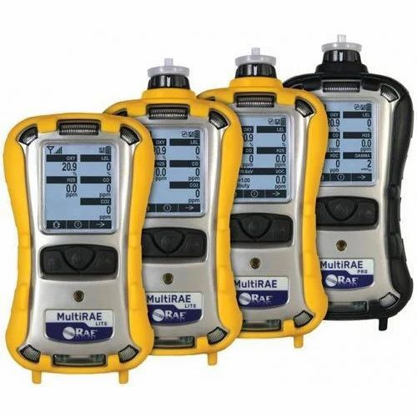

Figure 1: Examples of portable gas detector devices[19]

Most underground miners also use cable networks, mainly leaky feeders’ communication systems. Leaky feeder systems are used for basic telemetry and voice communications for data transmission from underground mines to the base station at the earth's surface. However, this system suffers from signal degradation, interference in the harsh underground environment, and limited scalability [20] [21]. Improvements in communications and information technologies in underground mines have led to the development of wireless technology[22] . Although most mining companies still use outdated cabled monitoring systems and gas detector devices, some adopt emerging wireless technology. For example, in China, Shangwan Coal Mine, Erdos, has implemented a robust, innovative system by upgrading its previously developed cable environmental monitoring system to a wireless sensor node. This system includes environmental monitoring and can carry out periodic inspections and interruptions. The IoT wireless network system uses Bluetooth (IEEE802.15), WiFi (IEEE802.11), WiMAX data transmission uses an Ultra-Wide Band, and IEEE 802.15.4 guides ZigBee to transmit data from the underground. Several researchers in underground mining have proposed new technology to monitor air quality, locate the underground miners, and monitor the roof stability[23], [24], [25], [26].

A hybrid system network for monitoring the underground environment is developed to address some challenges affecting underground miners' air quality monitoring. The designed system uses modern communications technologies like Internet of Things-enabled sensors, fiber optics system networks for data transmission, and an Xbee wireless communications network to provide real-time monitoring of underground parameters such as particulate matters, accumulated toxic gases, extreme temperatures, and humidity. The system also has automated emergency response mechanisms to trigger underground workers' alerts and guide the evacuation protocols when the parameters exceed the standard thresholds.

The key purpose of the designed hybrid monitoring system is to enhance underground mine safety by providing constant real-time monitoring of underground parameters. Fiber optics wire is chosen over a leaky feeder because fiber wire transmits data faster and can transmit a large volume of data compared to a leaky feeder[27]. The system ensures seamless communication between the underground worker and the controller at the surface station. This study is critical because it introduces an automatic emergency response that helps reduce delays during life-saving interventions. The research study for this paper uses fiber optics to transmit the data, although that is beyond the scope of this study.

Even though several commercial systems exist, such as traditional gas detectors, wireless sensor networks, and wired systems like leaky feeders, the available systems seemingly offer limited functionality to underground miners. The proposed hybrid system combines wireless, wired, and convectional gas detector capabilities into one integrated solution. For example, the conventional gas detector offers a low-cost portable device that is effective for periodic monitoring. However, the device lacks real-time data transmissions and multimeter-parameter integrations. The wired system provides a sensitivity and distributed monitoring system, but the system is expensive to deploy and maintain in large-scale mining. The wireless sensor network provides real-time monitoring capabilities to the underground miners, but their initial capital is costly. Also, they are limited by range and signal interference in a confined and dynamic environment. Merging the above technologies, the proposed system attains a balanced equilibrium between cost-effectiveness, functionality, and reliability. The system incorporates low-cost IoT-enabled sensors for widespread deployment, high efficiency for fiber optics data transmissions, and wireless communications networks using Xbees for seamless data transmissions and emergency alerts in busy production areas to avoid inconveniencies during mining operations.

The proposed system provides significant cost advantages over the wired system and provides continuous real-time data compared to multi-gas detector devices. The wired systems are expensive because of the constant moving of the wired system from one point to another as the mines go deeper. However, with a well-designed hybrid system, the cost of moving the wired system from one point to the other as the mines go deeper can be minimized by using wireless sensor networks. At some point, using hybrid can be cost-effective in large underground mines[28] This is because, in straight mines, an Xbee module can communicate 100 to 120 m, but in a curved mine, there will be reductions in the signal strength and packet loss[29].This means the initial cost of buying communication modules can be expensive, as one cost equals one kilometer. This hybrid system significantly impacts underground mines by providing a comprehensive solution for improving ground safety and operational efficiency in a harsh underground environment.

2. Design

The structure of the proposed Hybrid Monitoring System with Emergency Response Capabilities gathers environmental parameters in the underground mines using multiple sensors, such as MQ7, MQ135, DHT11, and SDS001. The collected data is first transmitted using the XBee module communication system before relaying to the underground stations through fiber optics. The fiber optics transmit the data to the surface stations. The designed structure comprises three main layers, i.e., perception, network, and applications.

**System Architecture**

The system architecture of the proposed hybrid monitoring system follows the three-layer framework.

***The Perception Layer***

This layer consists of sensor nodes. The layer collects environmental data from multiple sensors installed within the underground mines. These sensors measure underground environmental parameters and convert them to electrical signals for processing. The above sensors are integrated with a microcontroller for on-site data processing. The sensor node is placed strategically along the production area, where the sensors can measure accumulations of toxic gases such as carbon dioxide and carbon monoxide, particulate matter from blasting, diesel fumes from heavy machines, and extreme temperatures and humidity.

***Network Layer***

Using a hybrid communication system, this layer transmits collected data from the perception layer to the application layer. The layer comprises two communication systems: the XBee communication module and Fiber Optics. XBee communication modules provide a local wireless transmission between sensors and underground relay nodes, while fiber optics in the layer ensure a high-speed transmission from the underground mine relay node to the surface control stations. The hybrid approach in this layer is essential because it provides data integrity and minimizes the failure of data transmissions caused by underground environmental conditions.

***Application layer***

This layer serves as the interface between the users in the surface-controlled room and the system that performs real-time data monitoring, analysis, and visualization. The system analyzes the data using Raspberry Pi 4 as a local server.

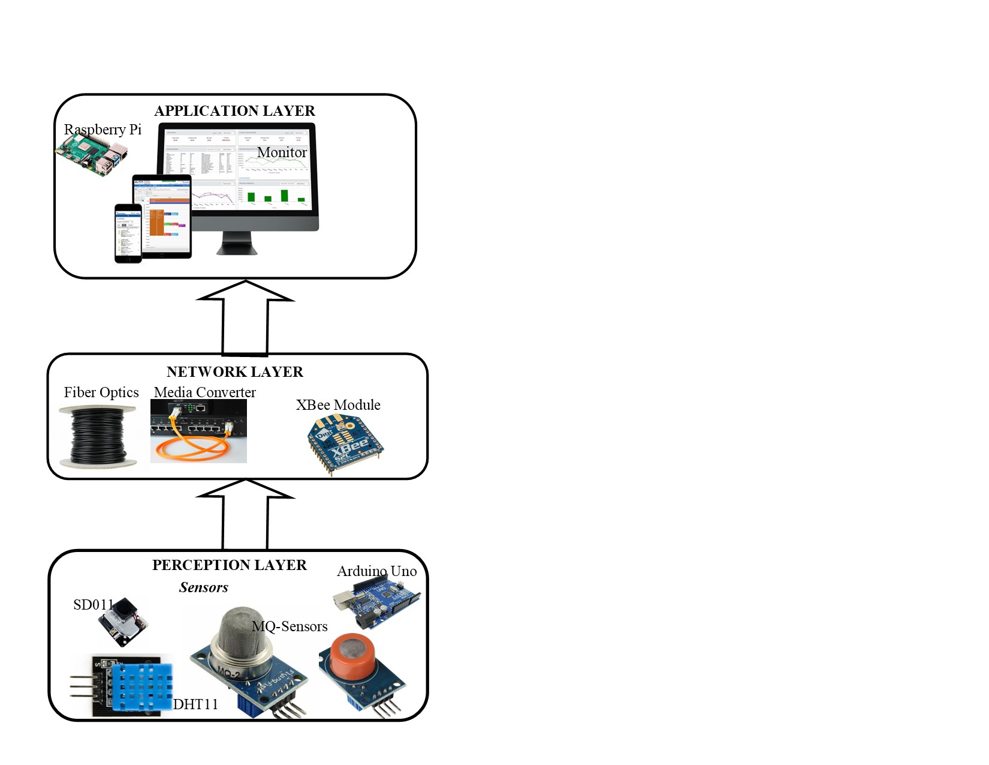

Figure 2 shows the components of each layer of the proposed system

Hardware Design and Rationale

The proposed system integrates Internet of Things-enabled sensors, a hybrid communication network, and an emergency response mechanism. The hardware in the perception layer consists of sensor nodes, the hardware in the network layer consists of communications modules, and the hardware in the application layer consists of the monitoring system.

**Perception Layer**

Sensor Nodes

Sensor nodes are critical components in the wireless sensor network and the Internet of Things used to collect underground environmental parameters. These nodes consist of four main components: sensing units, which include air quality monitoring sensors such as SD011, MQ7, MQ135, and DHT11.

MQ7-Sensor

This is a sensor gas designed to detect carbon monoxide (CO). It is highly useful in environments like underground mines, where CO is released during blasting and from heavy machines such as drilling machines. The sensors consist of a Tin Dioxide (SnO2) sensitive layer, a micro AL2O3 ceramic tube, a measuring electrode, and a heater fixed into a crust designed and integrated into plastic and stainless-steel nets. The heater in the device offers the necessary work conditions for sensitive components. The device operates on heated tin dioxide semiconductors, which change resistance depending on the CO concentration. The detection range for MQ7 is from 20 to 2000 ppm. The gas operates with 5V and has a preheating time of ≥48 hours for best stability[30]. The advantage of using MQ-7 over alternative sensors like electrochemical sensors is that MQ7 sensors are more cost-effective. Electrochemical sensors such as the Figaro TGS series provide better precision but are expensive and require frequent calibrations[31].

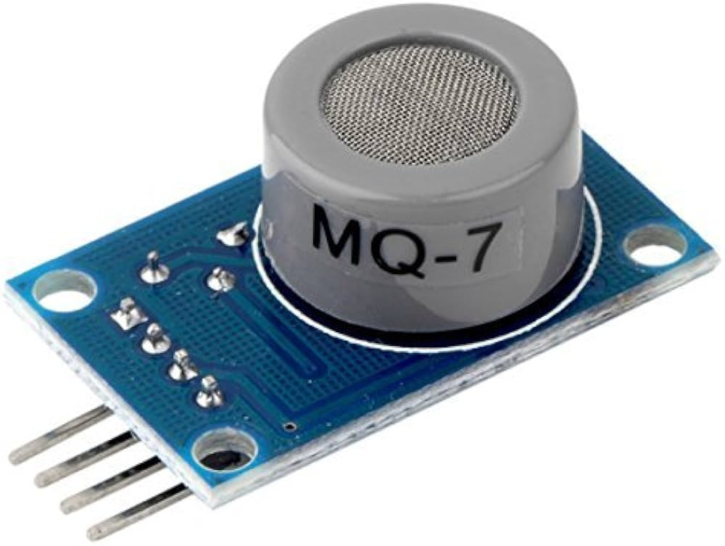

Figure 3 Shows MQ7-Sensor for monitoring CO gases

MQ 135-Sensor

MQ 135 Sensors are necessary gas sensors used to detect air quality by measuring levels of ammonia NH3, nitrogen oxides NOX, smoke, CO2, alcohol, and benzene in the air. This device operates on the principle of resistance variation in the presence of various gases, offering an analog voltage output read by microcontrollers like Arduino Uno. The advantage of selecting this sensor for underground purposes is that it is highly sensitive to toxic gases in a wide range. The gas has a long-life span and is cheap, with a 10-1000 ppm detection range. The gas has a preheat time of 48 hours and operates with 5V [32], [33]NDIR CO2 sensors are the best alternative sensors. However, they are expensive and can only detect CO2 gases, limiting the monitoring of other accumulated toxic gases in underground mines. Other sensors, like PAS gas monitors and open-path lasers, can be used, though they are expensive compared to MQ135 [34].

Table 1 shows a comparison of the MQ135 and alternative sensors[31], [32], [34], [35], [36]

|  |  |  |  |  |
| --- | --- | --- | --- | --- |
| **Feature** | **MQ-135 (MOS Sensor)** | **PAS Gas Monitor** | **OP-Laser Gas Detector** | **NDIR Sensor** |
| Cost | Low | Medium | High | Medium |
| Detection Range | ppm | ppb to ppm | ppm to % level | ppm |
| Selectivity | Low (multi-gas, non-specific) | High (specific gases) | Very High (specific gases) | High (specific gases) |
| Sensitivity | Low-Medium | High | Very High | High |
| Response Time | Moderate (seconds) | Fast (seconds) | Very Fast (milliseconds) | Fast (seconds) |
| Coverage Area | Point Detection | Point Detection | Long Distance (meters-km) | Point Detection |
| Line of Sight Needed? | No | No | Yes | No |
| Calibration Needed? | Frequent | Occasional | Occasional | Rare |
| Environmental Resistance | Moderate (affected by humidity, temp) | High (stable) | Moderate (affected by dust, fog) | High (stable) |

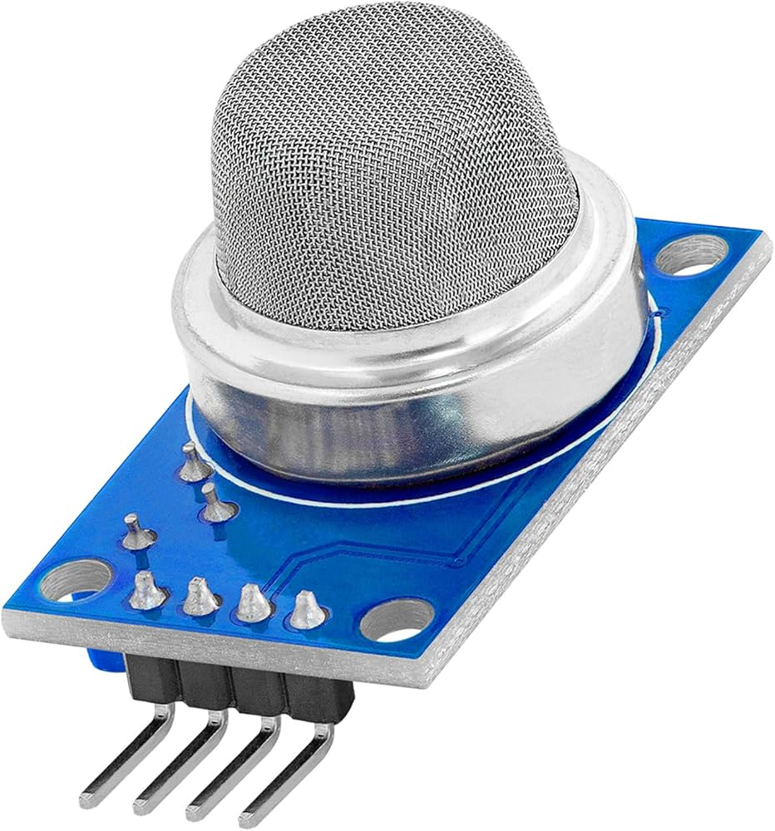

Figure 4 Show MQ 135 Sensors

SD011-Sensor

The SD011 is a particulate matter sensor designed to measure the PM2.5 and PM10 concentrations in the air. This technology operates using laser scattering. The particulate matter in the air scatters laser light, which is detected to determine the concentration of the particles in the air. Several alternative gases can be used instead of the SD011, such as Sharp GP2Y1010AU0F, Plantower PMS5003, and Honeywell HPMA115S0-XXX. However, SD011 sensors have an advantage over them because of their high accuracy, fast response time, affordability, and ease of integration. The challenge of using this device is that it consumes more power than its alternatives because of its built-in fan that enables air flow during its operations [37], [38], [39], [40], [41], [42], [43].

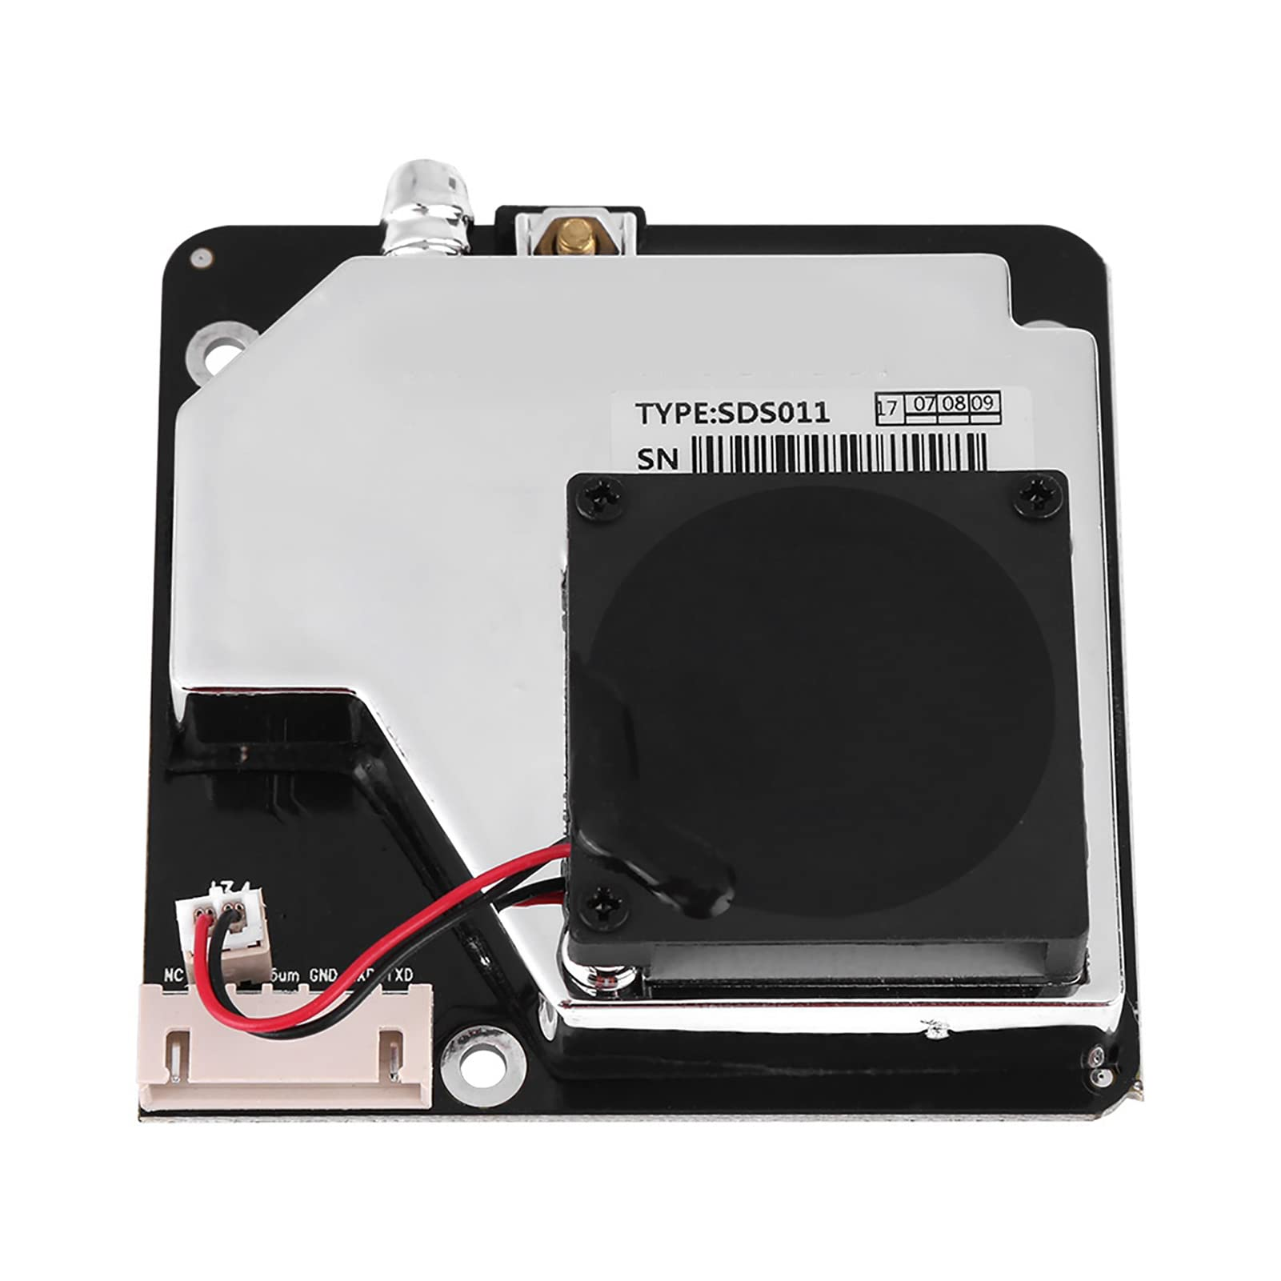

Figure 5 Shows SD011 Sensors

Table 2 Comparison of SD011 and alternative sensors[37], [38], [39], [40], [41], [42], [43], [44], [45]

|  |  |  |  |  |
| --- | --- | --- | --- | --- |
| **Feature** | **SDS011 (Particulate Sensor)** | **Sharp GP2Y1010AU0F** | **Plantower PMS5003** | **Honeywell HPMA115S0-XXX** |
| **Gases Detected** | PM2.5, PM10 | PM2.5, Dust (Particulate Matter) | PM1, PM2.5, PM10 | PM2.5, PM10 |
| **Accuracy** | ±10% for PM2.5 and PM10 | ±30% for PM2.5 | ±10% for PM1, PM2.5, PM10 | ±5% for PM2.5 and PM10 |
| **Response Time** | < 10 seconds | ~300 milliseconds | ~30 seconds | < 10 seconds |
| **Output Interface** | UART (Serial) | Analog output (Vout) | UART (Serial), I2C | UART (Serial) |
| **Power Consumption** | 150 mA (during operation) | 20-30 mA | 100 mA | 30-60 mA |
| **Size** | 71mm x 70mm x 23mm | 51mm x 43mm x 31mm | 61mm x 51mm x 24mm | 38mm x 20mm x 11mm |
| **Operating Humidity** | 0-95% RH (non-condensing) | 35-85% RH (non-condensing) | 0-99% RH (non-condensing) | 0-90% RH (non-condensing) |
| **Operating Temperature** | -10°C to 60°C | 0°C to 50°C | -10°C to 65°C | 0°C to 50°C |
| **Key Advantage** | It has a fast-response built-in fan for stable airflow | Low power, compact size | High precision with multi-particle size detection | Very compact, very accurate |
| **Key Limitation** | It's large because of the fan, hence higher power consumption | It is less accurate, and its analog output limits integration flexibility | It is more expensive and requires more complex integration | Expensive, less flexibility in mounting |
| **Best Use Case** | Generally used for air quality monitoring and IoT integration | Used for essential detection of air quality. | Used for high-precision multi-particle detection | Accurate, small form factor air quality monitoring |

DHT11-Sensor

The DHT11 sensors are commonly used to measure temperature and humidity. They are low-cost and easy to use because they are compatible with microcontrollers like Arduino Uno. The other advantage of using DHT11 sensors is that they consume little power and are widely available. The challenge of using this is that it has a limited range of 0 to 50 and low accuracy. The humidity range is (20%-90% RH) which is narrow compared to advanced technology. The possible alternative sensor that can be used is DHT22 (AM2302), which is slightly expensive compared to DHT11, even though it offers better accuracy and a wider range of measurements. The other sensors are BME280 and AM2320, which are more costly than the DHT11 sensors.

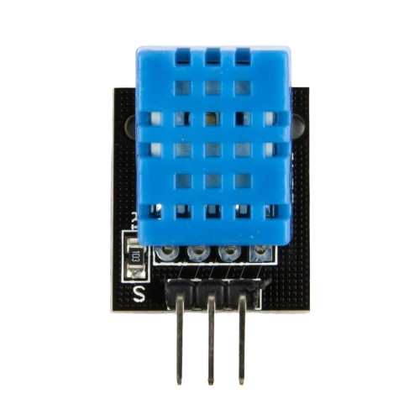

Figure 6 Shows DHT11 Sensors

Table 3 Shows the comparison between the DHT11 and other alternative sensors for temperature and humidity

|  |  |  |  |  |
| --- | --- | --- | --- | --- |
| **Feature** | **DHT11** | **DHT22 (AM2302)** | **BME280** | **AM2320** |
| **Type** | Temperature & Humidity Sensor | Temperature & Humidity Sensor | Temperature, Humidity & Pressure Sensor | Temperature & Humidity Sensor |
| **Temperature Range** | 0°C to 50°C | -40°C to 80°C | -40°C to 85°C | -40°C to 80°C |
| **Humidity Range** | 20% to 90% RH | 0% to 100% RH | 0% to 100% RH | 0% to 99.9% RH |
| **Temperature Accuracy** | ±2°C | ±0.5°C | ±1°C | ±0.5°C |
| **Humidity Accuracy** | ±5% RH | ±2-5% RH | ±3% RH | ±3% RH |
| **Resolution** | 8-bit (Temperature and Humidity) | 16-bit (Temperature and Humidity) | 16-bit (Temperature, Humidity & Pressure) | 16-bit (Temperature & Humidity) |
| **Response Time** | ~1 second | ~1 second | ~1 second | ~1 second |
| **Output Interface** | Digital (Single-wire) | Digital (Single-wire) | I2C/SPI | I2C |
| **Power Consumption** | Low (2-5 mA) | Low (1-2 mA) | Low (3.6 mA) | Low (2-4 mA) |
| **Operating Voltage** | 3.5V to 5.5V | 3.3V to 6V | 1.8V to 3.6V | 3.3V to 5V |
| **Size** | 40mm x 20mm x 12mm | 49mm x 25mm x 12mm | 3.3mm x 3.3mm x 1.0mm | 45mm x 24mm x 14mm |
| **Key Advantage** | Affordable, simple to use | Higher accuracy, wide range | Measures Temperature, Humidity, and Pressure | Reliable, suitable for low-cost projects |
| **Key Limitation** | Lower accuracy, limited range | More expensive than DHT11 | Requires more power and I2C/SPI interface | Slightly more costly than DHT11 |
| **Best Use Case** | Essential temperature & humidity monitoring | Precision applications, wider range | Advanced environmental monitoring (Temperature, Humidity, and Pressure) | Budget-friendly, suitable for general use |
| **Cost** | **Low** | **Moderate** | **High** | **Moderate** |

Microcontroller (Arduino Uno)

Arduino Uno is a widely used microcontroller. Arduino Uno has advantages over other microcontrollers such as Raspberry Pi, ESP32, and Arduino Nano. Its advantage is that it is user-friendly, flexible, and has significant community support and online resources. Arduino also has low power consumption and is suitable for battery-operated projects.

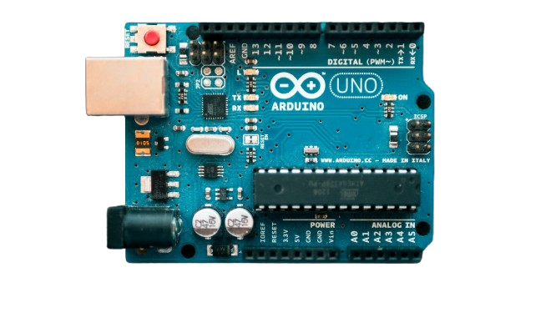

Figure 7 Shows Arduino Uno (Microcontroller)

Figure 8 Comparison of Arduino Uno with other alternatives

|  |  |  |  |  |  |
| --- | --- | --- | --- | --- | --- |
| **Feature** | **Arduino Uno** | **Arduino Nano** | **Raspberry Pi** | **ESP32** | **Teensy** |
| **Processor** | ATmega328P (16 MHz) | ATmega328P (16 MHz) | ARM Cortex-A72 (1.5 GHz) | Dual-core Xtensa (240 MHz) | ARM Cortex-M4 (72 MHz) |
| **Operating Voltage** | 5V | 5V | 5V (via USB) | 3.3V | 3.3V |
| **Digital I/O Pins** | 14 (6 PWM) | 14 (6 PWM) | 26 GPIO pins | 34 GPIO pins | 34 GPIO pins |
| **Analog I/O Pins** | 6 | 8 | None (GPIO pins can be used for analog input) | 18 | 12 |
| **PWM Pins** | 6 | 6 | Software PWM | 16 | 12 |
| **Clock Speed** | 16 MHz | 16 MHz | 1.5 GHz | 240 MHz | 72 MHz |
| **Memory** | 32 KB Flash, 2 KB SRAM | 32 KB Flash, 2 KB SRAM | 1 GB to 8 GB RAM (depending on model) | 520 KB SRAM, 4 MB Flash | 256 KB Flash, 64 KB SRAM |
| **USB Interface** | USB-B | USB mini | USB-C or micro-USB (depending on model) | USB-C | Micro-USB |
| **Connectivity** | None | None | Ethernet, Wi-Fi, Bluetooth | Wi-Fi, Bluetooth | None |
| **Power Consumption** | Low (50-100 mA) | Low (50-100 mA) | Higher (3-5 W) | Low (160 mA) | Low (20-50 mA) |
| **Size** | 68.6 mm x 53.4 mm | 45 mm x 18 mm | Varies (e.g., Raspberry Pi 4: 88 mm x 58 mm) | 60 mm x 25 mm | 35 mm x 18 mm |
| **Operating System** | None (Bare-metal programming) | None (Bare-metal programming) | Linux-based OS (Raspberry Pi OS, etc.) | None (Bare-metal programming) | None (Bare-metal programming) |
| **Key Advantage** | Easy to use, well-documented | Compact size, similar to Uno | High processing power, multitasking | Built-in Wi-Fi & Bluetooth, low-cost for IoT | High performance in small size |
| **Key Limitation** | Limited memory and power | Limited size and memory | Requires more power and OS knowledge | Limited I/O compared to Raspberry Pi | Limited by clock speed and memory |
| **Cost (Approx.)** | Low | Low | Moderate to High | Low | Moderate |

Power Unit Design

In designing an efficient and reliable power unit, it is vital to ensure stable power delivery, long operational duration, and energy efficiency. This system needs a robust power source capable of sustaining continuous operations while maintaining efficiency and safety. A 120,000mAh lithium-ion battery pack configured in the 3-series arrangements achieves this. The battery pack in the system provides a nominal voltage of 3.7 x 3=11.1V and a fully charged voltage of (4.2x 3 cells=12.6V). The total battery energy is 12.6v x 120 Ah = 1512Wh.

The 3S 40A Battery Management System is integrated into the power system and ensures the safety and longevity of the battery pack. The BMS plays a vital role in overcharge protection, which prevents the battery cells from exceeding the battery-safe voltage limits. It also helps over-discharge protections by safeguarding against excessive depletion that could damage the cells. It also helps cell balancing, ensuring that all battery cells maintain equal charge levels to enhance the overall efficiency and lifespan of the power system unit. In addition, the BMS helps with overcurrent protection features. It ensures the system does not draw excessive current beyond the pack’s safe limits, preventing overheating and possible failure.

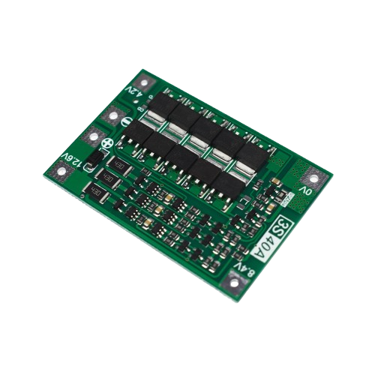

Figure 9 Shows Battery Management System

A DC-DC step-down (buck) converter converts the 12.6V output from the BMS to a stable 5V for the sensor nodes. The DC-DC step-down (buck) converter ensures efficient voltage regulation while minimizing power loss. This converter operates with approximately 90% efficiency. This means that most of the power withdrawn from the BMS system is converted into usable power. The converter supplies at least 2A current to run the system effectively. The system's total power consumption depends on each component's current requirement.

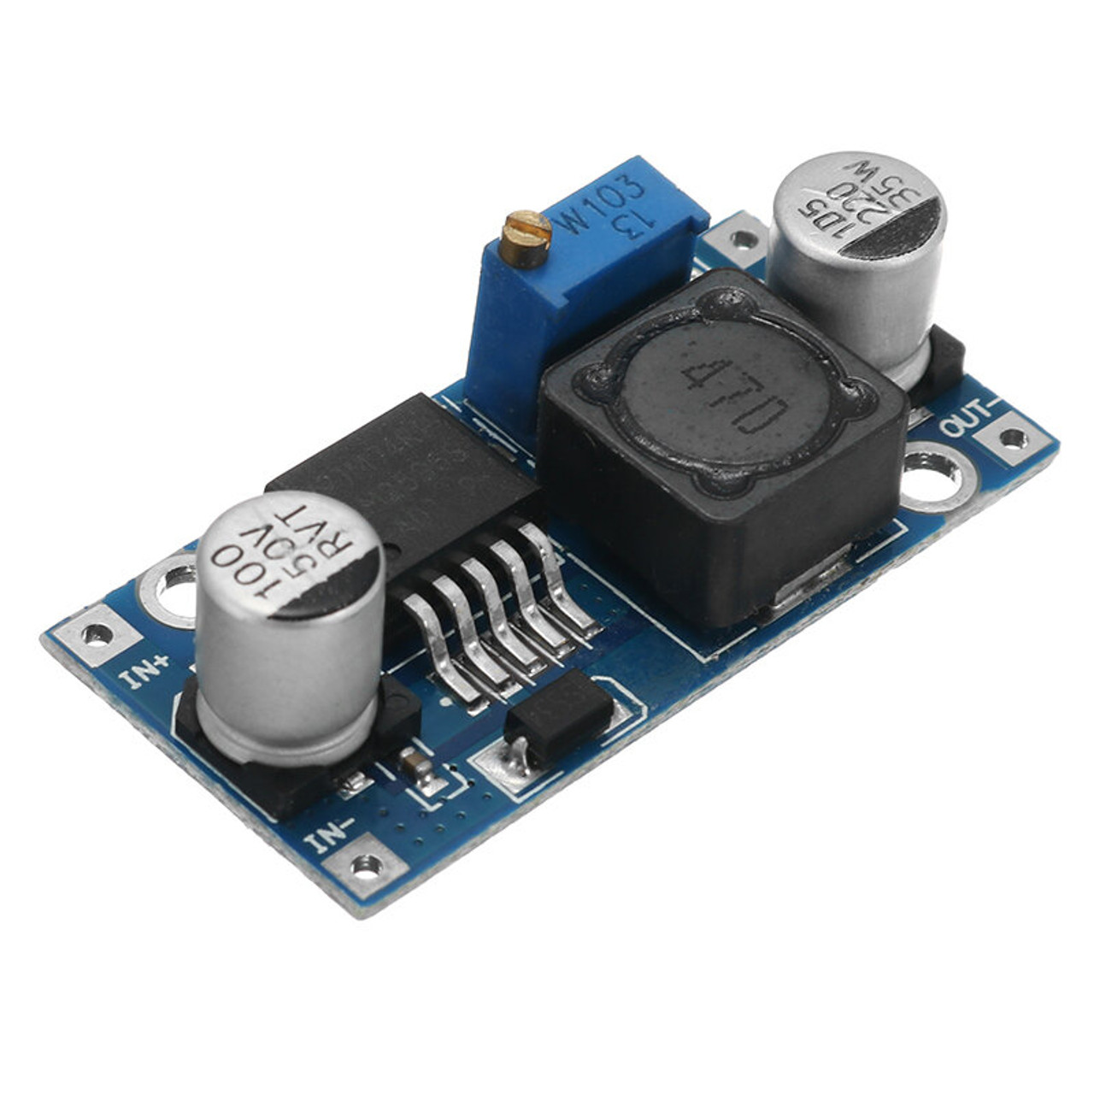

Figure 10 Show DC to DC converter

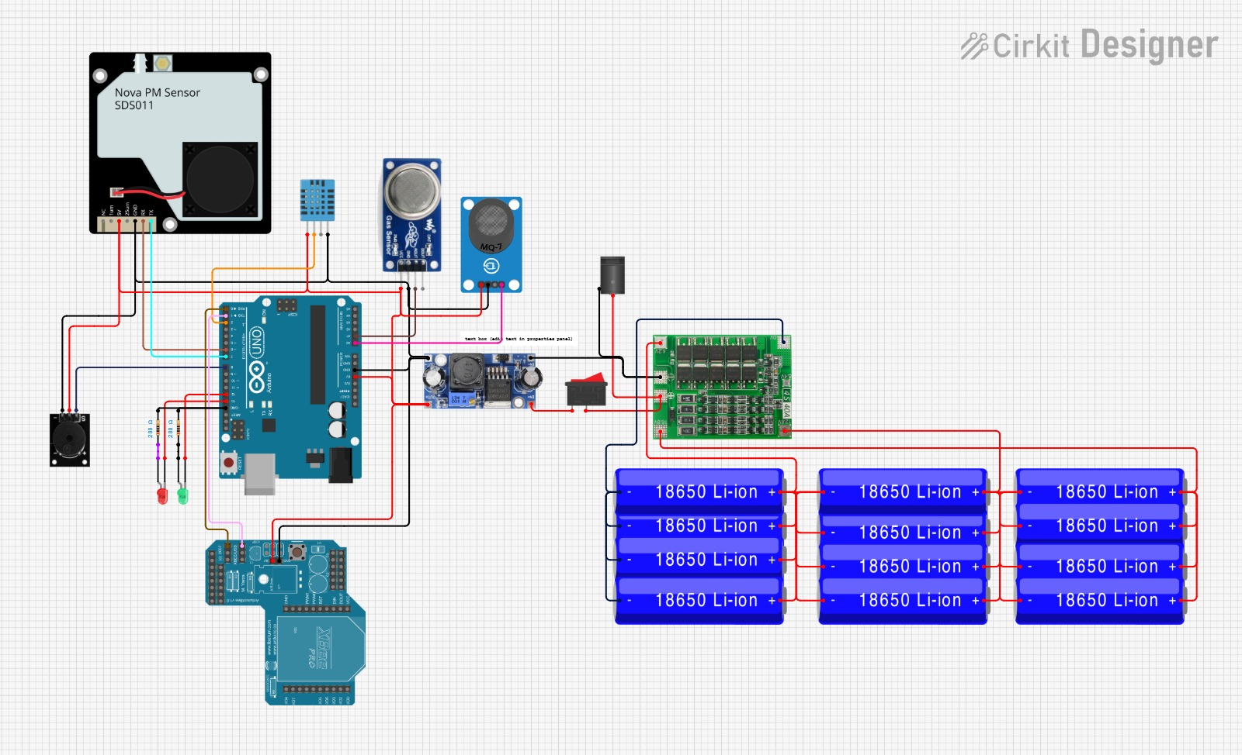

Figure 11 Shows the designed Sensor node system

**Network Layer**

This designed system employs XBee modules for wireless communication within short-range sensor networks and fiber-optic cables for long-distance communication to the control center. Combining these technologies enables free interference and an efficient and scalable communication network that suits underground applications.

**Short-range Wireless communication system**

The sensor information is transmitted to the relays and a local gateway through XBee modules. The XBee communication system's advantages are its low power consumption and robust mesh networking capacity. The system operates on the IEEE 802.15.4 standard, which is designed for low data rate and low power applications. One advantage of using the XBee module for this research is its ability to support a self-healing mesh network. Therefore, if one communication node fails, the transmitted data can be automatically rerouted through other nodes, enhancing system reliability. In addition, the XBee module offers up to 100 to 120 meters range in a confined indoors in line-of-sight conditions. When the XBee module is compared to other alternatives like Wi-Fi-based communications, XBee communication systems consume significantly less power, making it ideal for battery-powered sensor nodes. However, the limitation of using XBee modules is low data rate (250 kbps). This may not be sufficient for applications that require high-speed data transfer. Moreover, the XBee module has a shorter range than LoRa, another communication alternative supporting up to approximately 15 km. However, despite the advantages of the XBee module alternatives, it remains the best choice for underground networks. This is because of its power efficiency and ability to form reliable mesh networks.

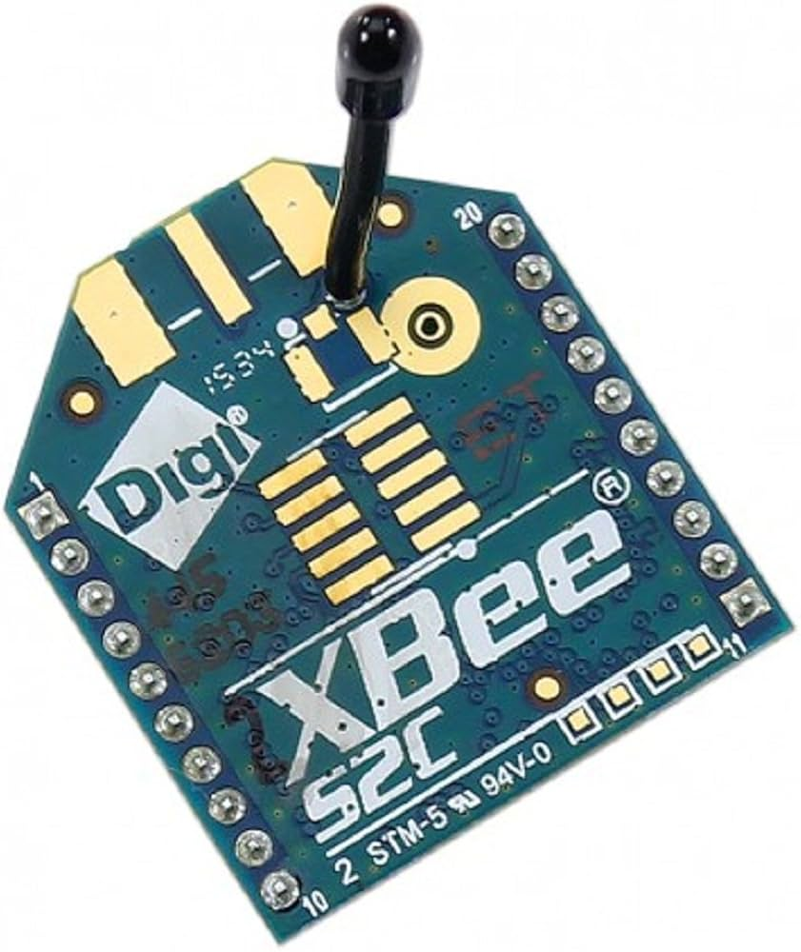

Figure 12 Shows XBee

Figure 13Show the comparison of XBee modules with other alternatives

|  |  |  |  |  |  |  |
| --- | --- | --- | --- | --- | --- | --- |
| **Technology** | **Range** | **Power Consumption** | **Data Rate** | **Interference Resistance** | **Mesh Networking** | **Cost** |
| **XBee (IEEE 802.15.4)** | **100m - 1.6km** | **Low** | **250 kbps** | **Moderate** | **Yes** | **Moderate** |
| **LoRa (Long Range Radio)** | **Up to 15 km** | **Very Low** | **50 kbps** | **High** | **Yes** | **Low** |
| **Wi-Fi (2.4GHz/5GHz)** | **50 - 100m** | **High** | **54 Mbps - 1Gbps** | **Low** | **No** | **Moderate** |
| **Bluetooth** | **10 - 50m** | **Moderate** | **1 Mbps - 3 Mbps** | **Low** | **No** | **Low** |
| **RF Modules (433MHz, 868MHz, 915MHz)** | **Up to 10 km** | **Very Low** | **9.6 - 115 kbps** | **High** | **No** | **Low** |

**Longer-Range Communications through Fiber-optic Cables**

Although the XBee modules are well suited for short-range communication in underground mines, they can experience challenges like metal interference and signal attenuation that weaken their wireless signals. To overcome these challenges, fiber-optic cables establish long-distance communication between the underground gateway and the surface control center. Fiber-optic is known for its minimal latency, high-speed data transmissions, and immunity to electromagnetic interference. It utilizes light signals instead of electrical signals, which enables faster and interference-free communication. The media converter converts the electrical signals from the sensors to light signals. This makes fiber optics suitable for an underground environment where signal attenuations disrupt underground communications. The main advantage of using fiber optics communications in this research over its alternative is its higher bandwidth capacity of up to 10 Gbs, lower signal degradation over long distances, and enhanced security against data interception. Besides, fiber optics offers stable connectivity over tens of kilometers, ensuring that real-time sensor data can be transmitted reliably to the surface monitoring station.

The challenge of using fiber optics is that its installations require specialized handling and expertise, making them more expensive than traditional Ethernet-based systems. Fiber optic cables are also more fragile than leaker feeders, and copper wireless cables are alternatives. This means that its installations require carefulness to prevent damage. Despite these challenges, using fiber optics for long-distance communication is justifiable because of its superior data integrity, speed, and reliability in harsh underground environments.

|  |  |  |  |  |  |
| --- | --- | --- | --- | --- | --- |
| **Technology** | **Range** | **Speed** | **Interference Resistance** | **Scalability** | **Cost** |
| **Fiber-Optic Cable** | **10 - 100 km** | **1 Gbps - 10 Gbps** | **Very High** | **High** | **High** |
| **Leaky Feeder System** | **Several km** | **100 Mbps - 1 Gbps** | **Moderate** | **Moderate** | **High** |
| **Twisted Pair Cable (Ethernet - Cat 6)** | **100m per segment** | **1 Gbps** | **Moderate** | **Moderate** | **Low** |
| **Coaxial Cable** | **Up to 500m** | **100 Mbps - 1 Gbps** | **High** | **Low** | **Moderate** |

Applications Layer

This layer is responsible for data processing, visualization, and decision-making. Raspberry Pi is the core of this layer, which acts as the central computing unit. It receives data sensors from the network layer and processes them to offer actionable insight. The layer enables real-time monitoring, data logging, alert triggering, and remote access to the underground environment. Raspberry pi4 has advantages over other alternatives because it is power efficient, has computing capability, and is cost-effective for real-time data processing. The only challenge of using Raspberry Pi is that it is inefficient for advanced artificial learning models.

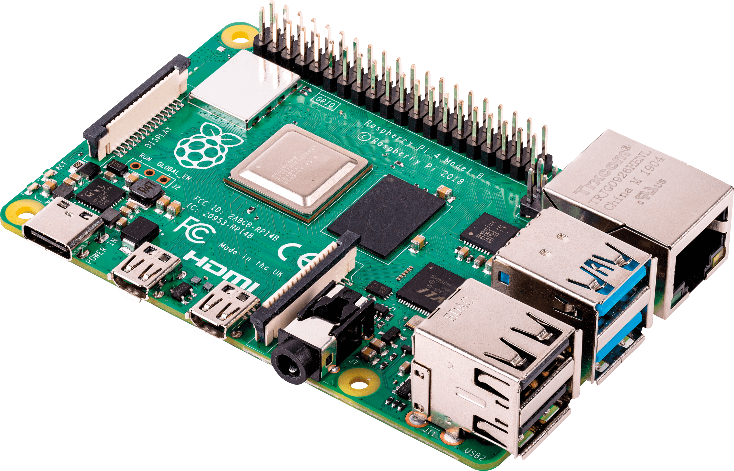

Figure 14 Raspberry P1 4

Figure 15:Shows comparision for Raspberry Pi 4 with alternatives

|  |  |  |  |  |  |  |
| --- | --- | --- | --- | --- | --- | --- |
| **Processing Unit** | **CPU Performance** | **Power Consumption** | **Connectivity** | **Storage** | **AI Capability** | **Cost** |
| **Raspberry Pi 4 (4GB RAM)** | **Quad-core 1.5GHz** | **Low (5V, 3A)** | **Wi-Fi, Bluetooth, USB, HDMI, GPIO** | **32GB+ (MicroSD)** | **Basic ML (Edge AI)** | **Moderate** |
| **Arduino Uno** | **8-bit (16MHz)** | **Very Low (5V, 500mA)** | **Limited (USB, Serial, I2C, SPI)** | **None (External EEPROM needed)** | **No AI support** | **Low** |
| **Jetson Nano (NVIDIA)** | **Quad-core 1.43GHz** | **High (5V, 4A)** | **Wi-Fi, USB, HDMI, GPIO, Ethernet** | **MicroSD (64GB+)** | **Advanced AI (Deep Learning)** | **High** |
| **BeagleBone Black** | **1GHz ARM Cortex-A8** | **Moderate (5V, 2A)** | **USB, GPIO, HDMI, Ethernet** | **4GB eMMC + MicroSD** | **Basic AI Support** | **Moderate** |

3. Build Instructions

Step-by-step instructions for building the hardware should be given here, referencing the design files and a bill of materials linked at the end of the article. The instructions should be sufficiently detailed to allow the reader to duplicate the device without becoming trivial by teaching the essentials of the techniques employed. If, for example, the building involves electronic circuitry, it can be assumed that the reader has a basic knowledge of electronics and the required construction techniques.

3.1. Subsection

3.1.1. Subsubsection

Bulleted lists look like this:

* First bullet;
* Second bullet;
* Third bullet.

Numbered lists can be added as follows:

1. First item;
2. Second item;
3. Third item.

The text continues here.

3.2. Figures, Tables and Schemes

All figures and tables should be cited in the main text as Figure 1, Table 1, etc.



**Figure 1.** This is a figure. Schemes follow the same formatting.

**Table 1.** This is a table. Tables should be placed in the main text near to the first time they are cited.

|  |  |  |
| --- | --- | --- |
| **Title 1** | **Title 2** | **Title 3** |
| entry 1 | data | data |
| entry 2 | data | data 1 |

1 Tables may have a footer.

The text continues here (Figure 2 and Table 2).

|  |  |
| --- | --- |
| C:\Users\martin\Downloads\testFigure.tif | C:\Users\martin\Downloads\testFigure.tif |
| (**a**) | (**b**) |

**Figure 2.** This is a figure. Schemes follow another format. If there are multiple panels, they should be listed as: (**a**) Description of what is contained in the first panel; (**b**) Description of what is contained in the second panel. Figures should be placed in the main text near to the first time they are cited.

**Table 2.** This is a table. Tables should be placed in the main text near to the first time they are cited.

|  |  |  |  |
| --- | --- | --- | --- |
| **Title 1** | **Title 2** | **Title 3** | **Title 4** |
| entry 1 * | data | data | data |
| data | data | data |
| data | data | data |
| entry 2 | data | data | data |
| data | data | data |
| entry 3 | data | data | data |
| data | data | data |
| data | data | data |
| data | data | data |
| entry 4 | data | data | data |
| data | data | data |

* Tables may have a footer.

3.3. Formatting of Mathematical Components

This is example 1 of an equation:

|  |  |
| --- | --- |
| a = 1, | (1) |

the text following an equation need not be a new paragraph. Please punctuate equations as regular text.

This is example 2 of an equation:

|  |  |
| --- | --- |
| a = b + c + d + e + f + g + h + i + j + k + l + m + n + o + p + q + r + s + t + u + v + w + x + y + z | (2) |

the text following an equation need not be a new paragraph. Please punctuate equations as regular text.

Theorem-type environments (including propositions, lemmas, corollaries etc.) can be formatted as follows:

**Theorem 1.** Example text of a theorem. Theorems, propositions, lemmas, etc. should be numbered sequentially (i.e., Proposition 2 follows Theorem 1). Examples or Remarks use the same formatting, but should be numbered separately, so a document may contain Theorem 1, Remark 1 and Example 1.

The text continues here. Proofs must be formatted as follows:

**Proof of Theorem 1.** Text of the proof. Note that the phrase “of Theorem 1” is optional if it is clear which theorem is being referred to. Always finish a proof with the following symbol. □

The text continues here.

4. Operating Instructions

Describe how to properly use the hardware.

5. Validation

Demonstrate that the device achieves its purpose. If the device is intended to measure something, carry out an example measurement and show the results in figures or tables. Verify the results with an alternative method if possible. Give statistical data if feasible.

6. Conclusions

Give a general discussion on whether the device fulfills the expected performance. Give an outlook regarding further developments if appropriate.

7. Patents

This section is not mandatory but may be added if patents result from the work reported in this manuscript.

**Supplementary Materials:** The following supporting information can be downloaded at: www.mdpi.com/xxx/s1, Figure S1: title; Table S1: title; Video S1: title.

|  |  |  |
| --- | --- | --- |
| Name | Type | Description |
| S1 | Python script (.py) | Script of python source code used in XX |
| S2 | Text (.txt) | Script of modelling code used to make Figure X |
| S3 | Text (.txt) | Raw data from experiment X |
| S4 | Video (.mp4) | Video demonstrating the hardware in use |
| ... | ... | ... |

**Author Contributions:** For research articles with several authors, a short paragraph specifying their individual contributions must be provided. The following statements should be used “Conceptualization, X.X. and Y.Y.; methodology, X.X.; software, X.X.; validation, X.X., Y.Y. and Z.Z.; formal analysis, X.X.; investigation, X.X.; resources, X.X.; data curation, X.X.; writing—original draft preparation, X.X.; writing—review and editing, X.X.; visualization, X.X.; supervision, X.X.; project administration, X.X.; funding acquisition, Y.Y. All authors have read and agreed to the published version of the manuscript.” Please turn to the [CRediT taxonomy](https://img.mdpi.org/data/contributor-role-instruction.pdf) for the term explanation. Authorship must be limited to those who have contributed substantially to the work reported.

**Funding:** Please add: “This research received no external funding” or “This research was funded by NAME OF FUNDER, grant number XXX” and “The APC was funded by XXX”. Check carefully that the details given are accurate and use the standard spelling of funding agency names at https://search.crossref.org/funding. Any errors may affect your future funding.

**Institutional Review Board Statement:** In this section, you should add the Institutional Review Board Statement and approval number, if relevant to your study. You might choose to exclude this statement if the study did not require ethical approval. Please note that the Editorial Office might ask you for further information. Please add “The study was conducted in accordance with the Declaration of Helsinki, and approved by the Institutional Review Board (or Ethics Committee) of NAME OF INSTITUTE (protocol code XXX and date of approval).” for studies involving humans. OR “The animal study protocol was approved by the Institutional Review Board (or Ethics Committee) of NAME OF INSTITUTE (protocol code XXX and date of approval).” for studies involving animals. OR “Ethical review and approval were waived for this study due to REASON (please provide a detailed justification).” OR “Not applicable” for studies not involving humans or animals.

**Informed Consent Statement:** Any research article describing a study involving humans should contain this statement. Please add “Informed consent was obtained from all subjects involved in the study.” OR “Not applicable.” for studies that did not involve humans. You might also choose to exclude this statement if the study did not involve humans.

Written informed consent for publication must be obtained from identifiable human participants. For studies involving client-owned animals written informed consent must be obtained from the owner of the animals (or an authorized agent for the owner).

**Data Availability Statement:** We encourage all authors of articles published in MDPI journals to share their research data. In this section, please provide details regarding where data supporting reported results can be found, including links to publicly archived datasets analyzed or generated during the study. Where no new data were created, or where data is unavailable due to privacy or ethical restrictions, a statement is still required. Suggested Data Availability Statements are available in section “MDPI Research Data Policies” at https://www.mdpi.com/ethics.

**Acknowledgments:** In this section, you can acknowledge any support given which is not covered by the author contribution or funding sections. This may include administrative and technical support, or donations in kind (e.g., materials used for experiments).

**Conflicts of Interest:** Declare conflicts of interest or state “The authors declare no conflicts of interest.” Authors must identify and declare any personal circumstances or interest that may be perceived as inappropriately influencing the representation or interpretation of reported research results. Any role of the funders in the design of the study; in the collection, analyses or interpretation of data; in the writing of the manuscript; or in the decision to publish the results must be declared in this section. If there is no role, please state “The funders had no role in the design of the study; in the collection, analyses, or interpretation of data; in the writing of the manuscript; or in the decision to publish the results”.

Abbreviations

The following abbreviations are used in this manuscript:

|  |  |
| --- | --- |
| MDPI | Multidisciplinary Digital Publishing Institute |
| DOAJ | Directory of open access journals |
| TLA | Three letter acronym |
| LD | Linear dichroism |

Appendix A

Appendix A.1

The appendix is an optional section that can contain details and data supplemental to the main text—for example, explanations of experimental details that would disrupt the flow of the main text but nonetheless remain crucial to understanding and reproducing the research shown; figures of replicates for experiments of which representative data is shown in the main text can be added here if brief, or as Supplementary data. Mathematical proofs of results not central to the paper can be added as an appendix.

**Table A1.** This is a table caption.

|  |  |  |
| --- | --- | --- |
| **Title 1** | **Title 2** | **Title 3** |
| entry 1 | data | data |
| entry 2 | data | data 1 |

Appendix B

All appendix sections must be cited in the main text. In the appendices, Figures, Tables, etc. should be labeled starting with “A”—e.g., Figure A1, Figure A2, etc.

References

References must be numbered in order of appearance in the text (including citations in tables and legends) and listed individually at the end of the manuscript. We recommend preparing the references with a bibliography software package, such as EndNote, ReferenceManager or Zotero to avoid typing mistakes and duplicated references. Include the digital object identifier (DOI) for all references where available.

Citations and references in the Supplementary Materials are permitted provided that they also appear in the reference list here.

In the text, reference numbers should be placed in square brackets [ ] and placed before the punctuation; for example [1], [1–3] or [1,3]. For embedded citations in the text with pagination, use both parentheses and brackets to indicate the reference number and page numbers; for example [5] (p. 10), or [6] (pp. 101–105).

[1] P. Parra, “Toxic Gases in Mining,” *International Journal of Engineering and Management Research*, vol. 11, no. 4, pp. 239–241, 2021.

[2] J. Menéndez *et al.*, “Concentration, propagation and dilution of toxic gases in underground excavations under different ventilation modes,” *Int J Environ Res Public Health*, vol. 19, no. 12, p. 7092, 2022.

[3] I. Al Balushi and S. M. Hussain, “IoT Based air Quality Monitoring and Controlling in Underground MINES,” *Journal of Student Research*, 2021.

[4] S. Roy, D. P. Mishra, R. M. Bhattacharjee, and H. Agrawal, “Heat stress in underground mines and its control measures: A systematic literature review and retrospective analysis,” *Min Metall Explor*, vol. 39, no. 2, pp. 357–383, 2022.

[5] S. K. Reddy, A. S. Naik, and G. R. Mandela, “Wireless monitoring of environmental parameters for underground mining using Internet of Things with LoRa transceiver module,” in *2022 IEEE 7th International Conference on Recent Advances and Innovations in Engineering (ICRAIE)*, IEEE, 2022, pp. 224–229.

[6] J. C. Kurnia, A. P. Sasmito, W. Y. Wong, and A. S. Mujumdar, “Prediction and innovative control strategies for oxygen and hazardous gases from diesel emission in underground mines,” *Science of the Total Environment*, vol. 481, pp. 317–334, 2014.

[7] S. Peters, N. de Klerk, A. Reid, L. Fritschi, A. W. B. Musk, and R. Vermeulen, “Estimation of quantitative levels of diesel exhaust exposure and the health impact in the contemporary Australian mining industry,” *Occup Environ Med*, vol. 74, no. 4, pp. 282–289, 2017.

[8] K. Rumchev, D. Van Hoang, and A. H. Lee, “Exposure to dust and respiratory health among Australian miners,” *Int Arch Occup Environ Health*, vol. 96, no. 3, pp. 355–363, 2023.

[9] S. Matloob, L. Yang, Q. M. Kashif, and F. Shah, “Continuous monitoring of coal mine dangers with an automated internet of things system,” *International Journal of Science and Research Archive*, vol. 12, no. 2.

[10] B. W. Jo and R. M. A. Khan, “An event reporting and early-warning safety system based on the internet of things for underground coal mines: A case study,” *Applied Sciences*, vol. 7, no. 9, p. 925, 2017.

[11] B. Jo and R. M. A. Khan, “An internet of things system for underground mine air quality pollutant prediction based on azure machine learning,” *Sensors*, vol. 18, no. 4, p. 930, 2018.

[12] N. M. Shahani *et al.*, “Statistical analysis of fatalities in underground coal mines in Pakistan,” *Energy sources, part a: recovery, utilization, and environmental effects*, vol. 47, no. 1, pp. 2189–2204, 2025.

[13] W. Gong *et al.*, “Recent advances in laser gas sensors for applications to safety monitoring in intelligent coal mines,” *Front Phys*, vol. 10, p. 1058475, 2022.

[14] S. K. Reddy, A. S. Naik, and G. R. Mandela, “Development of a reliable wireless communication system to monitor environmental parameters from various positions of underground mines to the surface using ZigBee modules,” *Journal of The Institution of Engineers (India): Series D*, vol. 105, no. 1, pp. 359–383, 2024.

[15] O. Stoicuta, S. Riurean, S. Burian, M. Leba, and A. Ionica, “Application of optical communication for an enhanced health and safety system in underground mine,” *Sensors*, vol. 23, no. 2, p. 692, 2023.

[16] B. Ziętek, A. Banasiewicz, R. Zimroz, J. Szrek, and S. Gola, “A portable environmental data-monitoring system for air hazard evaluation in deep underground mines,” *Energies (Basel)*, vol. 13, no. 23, p. 6331, 2020.

[17] Y. Guo *et al.*, “A portable laser-based sensor for detecting H2S in domestic natural gas,” *Infrared Phys Technol*, vol. 105, p. 103153, 2020.

[18] N. X. Thai *et al.*, “Realization of a portable H2S sensing instrument based on SnO2 nanowires,” *Journal of Science: Advanced Materials and Devices*, vol. 5, no. 1, pp. 40–47, 2020.

[19] Rev J, “MultiRAE Series User’s Guide,” 2017. [Online]. Available: http://www.raesystems.com/support/product-registration

[20] H. Zhang, B. Li, M. Karimi, S. Saydam, and M. Hassan, “Recent advancements in IoT implementation for environmental, safety, and production monitoring in underground mines,” *IEEE Internet Things J*, vol. 10, no. 16, pp. 14507–14526, 2023.

[21] S. C. Bakshi, A. Pramanik, G. C. Roy, and E. Saicharan, “On IoT based Underground Mine Environment Monitoring Systems,” in *Proceedings of the 26th International Conference on Distributed Computing and Networking*, 2025, pp. 352–357.

[22] G. Thirumal and C. Kumar, “Multilevel sensor deployment approach in IIoT-based environmental monitoring system in underground coal mines,” *Comput Commun*, vol. 195, pp. 1–13, 2022.

[23] J. Pramanik, S. Jayanthu, and D. A. K. Samal, “Applications of IoT Framework for Underground Mine Safety: Limitations and Solutions,” *Journal of Mining and Environment*, vol. 15, no. 3, pp. 923–942, 2024.

[24] A. G. Mohapatra *et al.*, “Precision local positioning mechanism in underground mining using IoT-enabled WiFi platform,” *International Journal of Computers and Applications*, vol. 42, no. 3, pp. 266–277, 2020.

[25] D. Haripranesh, L. Arulmurugan, P. Gopinath, and B. Kumar, “IoT-Driven Roof Support Management in Underground Mining: Enhancing Safety and Efficiency”.

[26] Y. Jiang, W. Chen, X. Zhang, X. Zhang, and G. Yang, “Real-Time Monitoring of Underground Miners’ Status Based on Mine IoT System,” *Sensors*, vol. 24, no. 3, p. 739, 2024.

[27] V. Yugay *et al.*, “Fiber-optic system for monitoring pressure changes on mine support elements,” *Sensors*, vol. 22, no. 5, p. 1735, 2022.

[28] H. Ikeda, O. Kolade, L. Cheng, F. Cawood, and Y. Kawamura, “Development of underground communication system for data transmission using Wi-Fi direct and power line communication,” *Tunnelling and Underground Space Technology*, vol. 153, p. 106047, 2024.

[29] S. K. Reddy, A. S. Naik, and G. R. Mandela, “Development of a reliable wireless communication system to monitor environmental parameters from various positions of underground mines to the surface using ZigBee modules,” *Journal of The Institution of Engineers (India): Series D*, vol. 105, no. 1, pp. 359–383, 2024.

[30] P. By alldatasheetcom, “MQ-7 HANWEI | Alldatasheet.” [Online]. Available: http://www.hwsensor.com

[31] “TGS 5042 (1120)”.

[32] “MQ135 Semiconductor Sensor for Air Quality Control.”

[33] P. By ALLDATASHEETCOM, “MQ135 WINSEN | Alldatasheet,” 2015. [Online]. Available: www.winsen-sensor.com

[34] M. Toat, S. Soekirno, and F. Faisal, “Monitoring system for carbon dioxide gas concentration using NDIR sensors,” in *AIP Conference Proceedings*, AIP Publishing, 2023.

[35] P. By ALLDATASHEETCOM, “MQ135 WINSEN | Alldatasheet,” 2015. [Online]. Available: www.winsen-sensor.com

[36] L. HANWEI  ELECTRONICS CO ., “MQ7-Sensors Data Sheet.”

[37] “Laser PM2.5 Sensor specification Product model: SDS011 Version: V1.3.”

[38] B. Laquai and B. Kroseberg, “Comparison of a Computational Method for Correcting the Humidity Influence with the Use of a Low-Cost Aerosol Dryer on a SDS011 Low-Cost PM-Sensor,” 2021.

[39] K. Kaur and K. E. Kelly, “Performance evaluation of the Alphasense OPC-N3 and Plantower PMS5003 sensor in measuring dust events in the Salt Lake Valley, Utah,” *Atmos Meas Tech*, vol. 16, no. 10, pp. 2455–2470, 2023.

[40] “Digital universal particle concentration sensor PMS5003 series data manual,” 2016.

[41] H. International Inc, “HPM Series Particle Sensor.”

[42] D. Mark, “Die stamp marking : Ink stamp marking 1st digit 2nd digit Year of production Month of production A.”

[43] J. E. Thompson, “Improved measurement performance for the sharp gp2y1010 dust sensor: Reduction of noise,” *Atmosphere (Basel)*, vol. 12, no. 6, p. 775, 2021.

[44] A. Simo, S. Dzitac, I. Dzitac, M. Frigura-Iliasa, and F. M. Frigura-Iliasa, “Air quality assessment system based on self-driven drone and LoRaWAN network,” *Comput Commun*, vol. 175, pp. 13–24, 2021.

[45] K. Kaur and K. E. Kelly, “Laboratory evaluation of the Alphasense OPC-N3, and the Plantower PMS5003 and PMS6003 sensors,” *J Aerosol Sci*, vol. 171, p. 106181, 2023.

2. Author 1, A.B.; Author 2, C.D. Title of the article. *Abbreviated Journal Name* **Year**, *Volume*, page range.
3. Author 1, A.; Author 2, B. Title of the chapter. In *Book Title*, 2nd ed.; Editor 1, A., Editor 2, B., Eds.; Publisher: Publisher Location, Country, 2007; Volume 3, pp. 154–196.
4. Author 1, A.; Author 2, B. *Book Title*, 3rd ed.; Publisher: Publisher Location, Country, 2008; pp. 154–196.
5. Author 1, A.B.; Author 2, C. Title of Unpublished Work. *Abbreviated Journal Name* year, *phrase indicating stage of publication (submitted; accepted; in press)*.
6. Author 1, A.B. (University, City, State, Country); Author 2, C. (Institute, City, State, Country). Personal communication, 2012.
7. Author 1, A.B.; Author 2, C.D.; Author 3, E.F. Title of Presentation. In Proceedings of the Name of the Conference, Location of Conference, Country, Date of Conference (Day Month Year).
8. Author 1, A.B. Title of Thesis. Level of Thesis, Degree-Granting University, Location of University, Date of Completion.
9. Title of Site. Available online: URL (accessed on Day Month Year).

**Disclaimer/Publisher’s Note:** The statements, opinions and data contained in all publications are solely those of the individual author(s) and contributor(s) and not of MDPI and/or the editor(s). MDPI and/or the editor(s) disclaim responsibility for any injury to people or property resulting from any ideas, methods, instructions or products referred to in the content.